Circuit Diagram and Explanation

Circuit connections of this project are very simple. Bluetooth module’s Rx and Tx pins are directly connected to the Tx and Rx pins of Microcontroller. Three 5 volt relays are used as a switch for turning ON and OFF the home appliances running on AC mains. And a relay driver ULN2003A is used for driving relays. Fan, Light and TV are connected at P1.3, P1.4 and P1.5 through relays and relay driver. An 11.0592 MHz crystal oscillator is used in this circuit for generating clock signal for microcontroller. And a 5 volt voltage regulator LM7805 is used for provide 5 volt for the whole circuit.

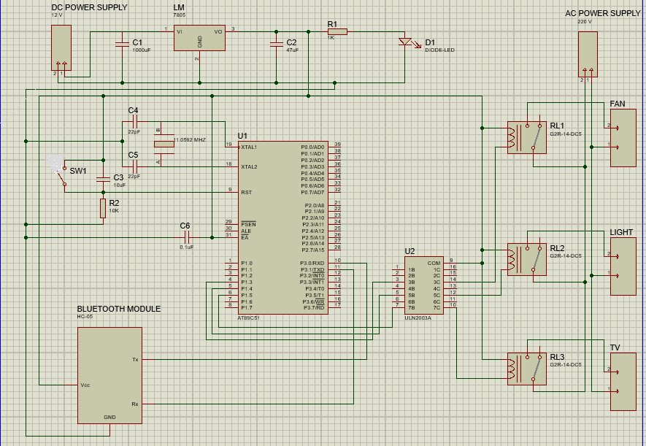

So that’s how we can create a whole system for the house and can connect all the AC appliances to the 8051 microcontroller using Relays. And this Bluetooth controlled home automation system can be operated from a Smart phone.